**SRINIVAS UNIVERSITY**

**INSTITUTE OF PHYSIOTHERAPY**

**A one day free Physiotherapy camp was conducted at Cascia church grounds on 15th September 2019.**

A one day free Physiotherapy camp was conducted at Cascia church grounds on 15th September under the guidance of Dr. Deepak Kumar Pradhan, Lecturer of College of Physiotherapy, Srinivas University. People around the locality had come to get their screening done. Many patients were identified with back pain, leg pain, vestibular issues and Diabetic Neuropathy. Basic treatment techniques were applied and home advice was given.

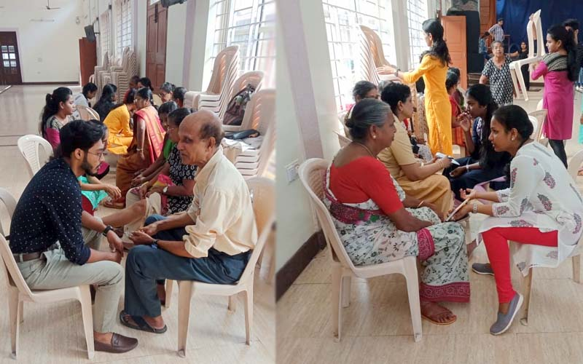

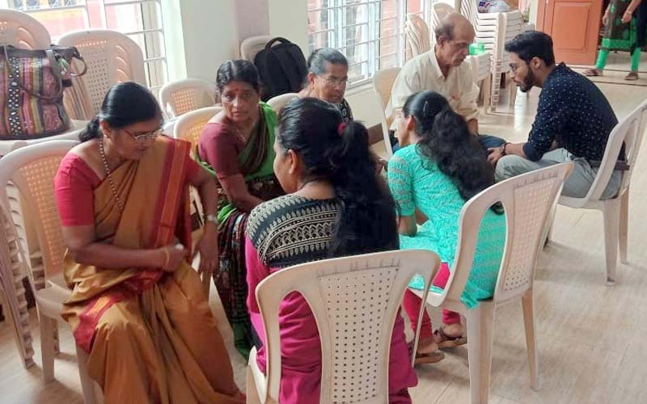

**A camp Postural awareness program for dental sciences on 25th & 26th of February 2022.**

Institute of Physiotherapy Srinivas University, city campus Pandeshwar organized a camp Postural awareness program for dental sciences on 25th & 26th of February 2022 at Srinivas College of Dental Science, Mukka. The camp was headed by Dr Aishwarya Nitin Sonwane delivered a gross introduction to work hazards and had a detailed discussion on the complications under the direct guidance of the Dean, Dr Rajasekar. During the camp. on the first day, February 25, 100 students including PG students & interns were educated while on the second day, February 26, 100 students in third & fourth years were educated. They were made aware of the preventive measures & precautions for the risk factors. Also were introduced to various ergonomic modifications as well as the quick exercise at the work place. The exercises were demonstrated by MPT volunteers with the detail of its benefits. Later, screening sessions of individual students were conducted and soon after the identification of risk factors, a necessary treatment combined with exercises was prescribed.

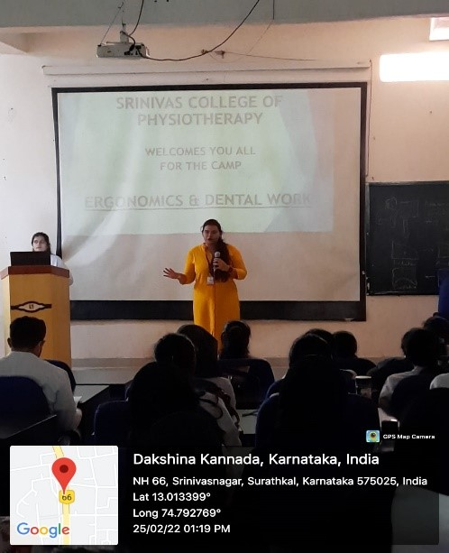

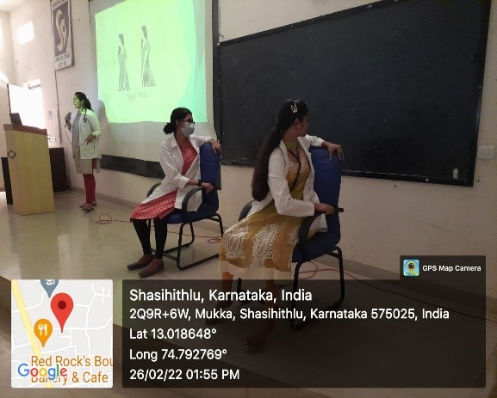

**A camp Diabetes mellitus Camp from 22nd to 28th of May 2022.**

Institute of Physiotherapy Srinivas University, city campus Pandeshwar organized a camp Diabetes mellitus Camp from 22nd to 28th of May 2022. The camp was headed by Dr. Premkumar with the team members (Dr Aishwarya Nitin Sonwane, Dr. Harsha, Dr. Tamilalagan and Dr. Vishagah) provides free service to all the Diabetes affected people under the direct guidance of the Dean, Dr Rajasekar. During the camp, almost 30 students including PG students & interns participated actively proving the service. This program included free testing of Sugar and BP (Blood pressure) by the trained nursing staff and free individual consultation form the Physician from Srinivas Institute of Medical Sciences and Research Centre, Srinivas Hospital, Mukka. Addition to this complete screening, identification if the problems, intervention was given. The exercises were demonstrated by MPT volunteers with the detail of its benefits. Later the patients were given a prescription for the purpose of follow up if required. Approximately 90 patients were screened and provided all the necessary services on account of their benefits.

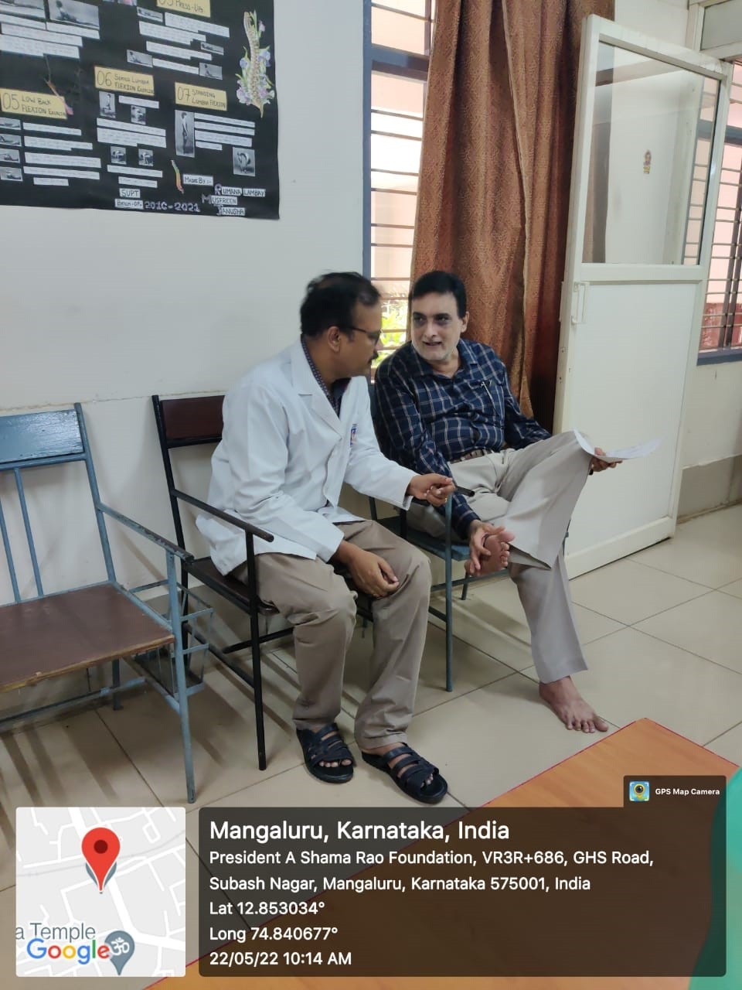

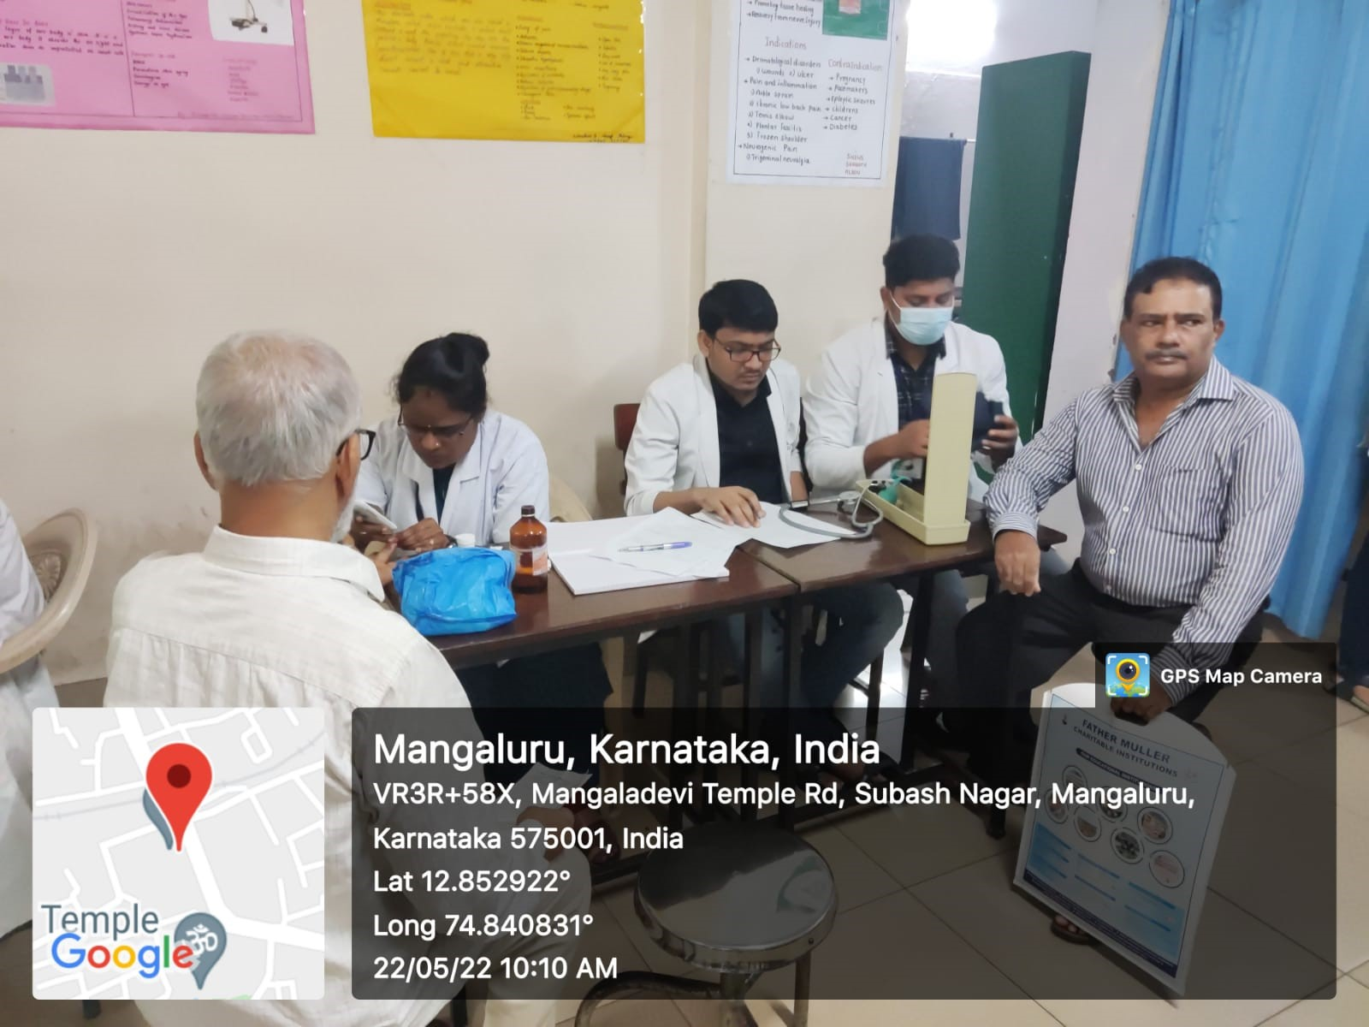

**On 24th of May 2022 in an Old age Home - Prashantha Nivas. Srinivas Institute of Physiotherapy City Campus Pandeshwar arranged an Activity Camp for all the Geriatric Population.**

On 24th of May 2022 in an Old age Home - Prashantha Nivas. Srinivas Institute of Physiotherapy City Campus Pandeshwar arranged an Activity Camp for all the Geriatric Population by Assistant Professor Dr. Aishwarya Nitin Sonwane (Community Physiotherapist) along with the BPT and MPT students under the guidance of Dean Dr. S. Rajasekar. Different Fun games were conducted where we focused on involving all the elderly people in a Physical Activity, so as to improve their performance in day-to-day life. As the sports and Games helps in improving blood circulation, musculoskeletal functioning, maintains good mental state of mind and ample number of aspects that can lead to overall improvement in an individual.

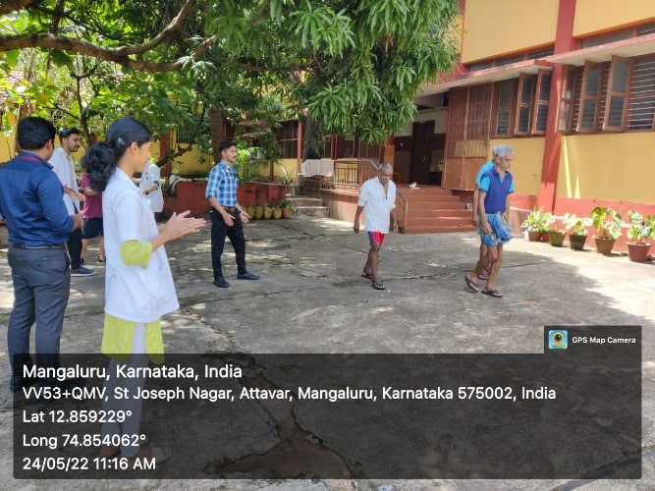 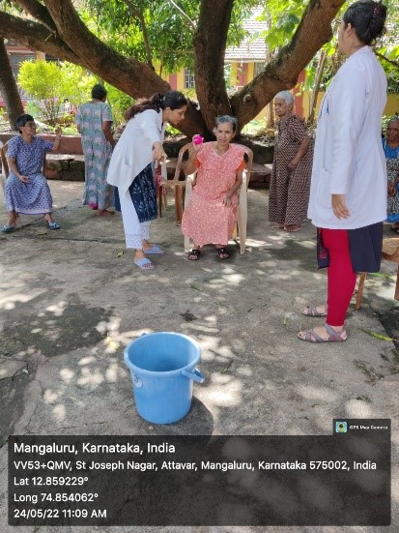

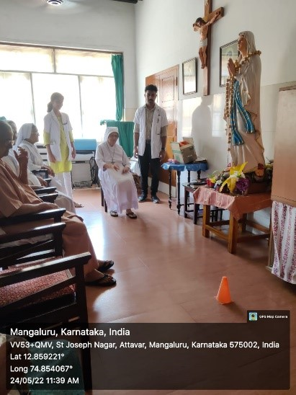 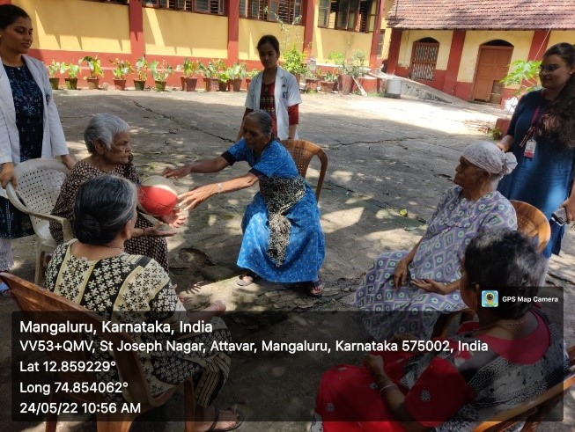

**NSS unit of Institute of Physiotherapy, Srinivas University in collaboration with the Blood Bank, Srinivas Hospital, Mukka organized one day blood donation camp on account of the World Blood Donors Day on 14th June 2022 at City campus, Pandeshwar.**

NSS unit of Institute of Physiotherapy, Srinivas University in collaboration with the Blood Bank, Srinivas Hospital, Mukka organized one day blood donation camp on account of the World Blood Donors Day on 14th June 2022 at City campus, Pandeshwar. The camp started at 9.30am with Dean, Dr. Rajasekar S donating blood. A group of 3 doctors, 3 Lab Technicians & 4 assistants from Srinivas Institute of Medical Sciences Hospital were present for conducting the camp. Before the donation, the donors were asked to fill a medical form to give details about their health-related information to check eligibility. Over 60 donors including faculty and students participated in this camp. The donors were provided with refreshments and certificates of donation.

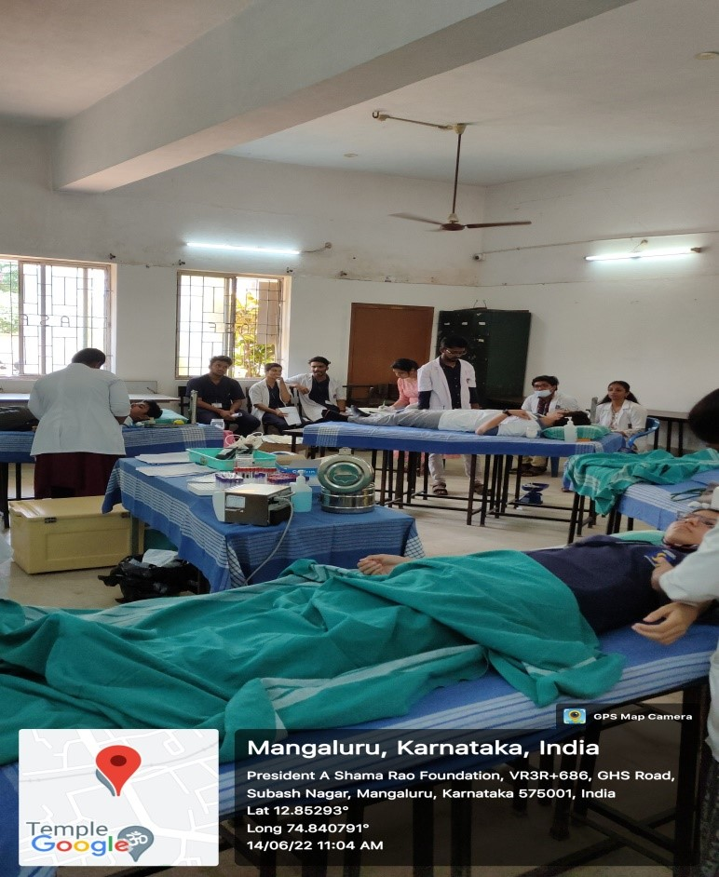

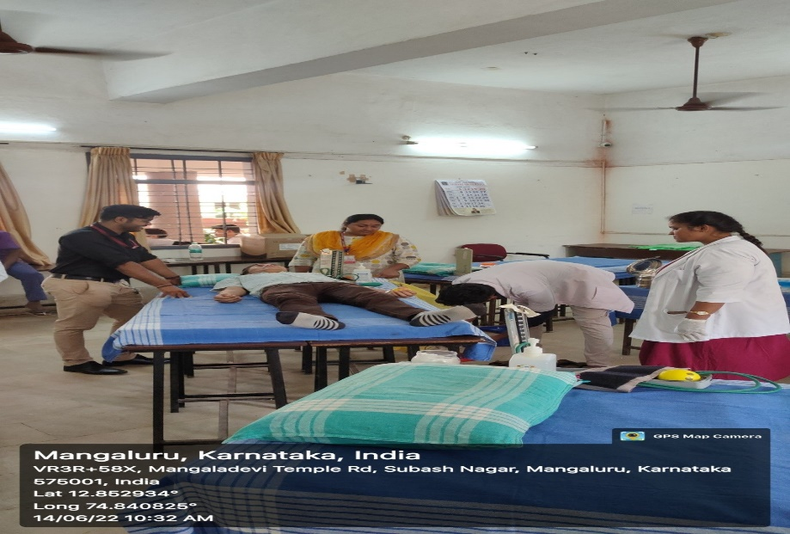

**Free Physiotherapy Camp for Osteoarthritic Knee pain patients on 06/09/2022.**

On the occasion of the World Physiotherapy Day celebration with the universal theme of osteoarthritis, Institute of Physiotherapy, Srinivas University organised an Osteoarthritis awareness Mini marathon on 06.09.2022, Tuesday morning 7 am within the Mangalore city and covered distance of 7km. The program was inaugurated by Dr. Kamalakannan and Dr. Premkumar, Faculties of Physiotherapy, Srinivas University. Around 80 runners including staffs and students took part in this awareness marathon with the moto of giving awareness to general public regarding osteoarthritis and role of physiotherapy in preventing and managing osteoarthritis. Six stations were arranged in different areas of the city for providing water and energy drink for the runners. The public were also provided with the pamphlets and encouraged them to attend the free physiotherapy camp held at physiotherapy OPD, in Pandeswar campus for diagnosing osteoarthritis and providing treatment with preventive measures. The valediction of completion of marathon was done by respectful Assistant Commissioner of Police Traffic, Mrs.Geetha Kulkarni. Dr.S.Rajasekar, Dean, Institute of Physiotherapy conveyed his gratitude to the Police department for their guidance in making the marathon a great success without affecting the public transport.

